# ESTUDIEZ

# PORTAL

|  |
| --- |
| **SOFTWAVE REQUIREMENTS SPECIFICATION** |
| **VERSION 1.0** |

### LINK DEMO

Team’s website: <https://phuopham.github.io/Techwiz2022/#!/>

Source code on GitHub: <https://github.com/phuopham/Techwiz2022>

Data access:

1. Student: Nguyen Hoang Nam
2. Teacher: Le Kim Tung
3. Parent: Tran Duy Anh

### PROBLEM DEFINITION

Nowadays, education and training is a field that plays an important role for all countries and ethnic groups at all times. In today’s trend of knowledge development, education – training is considered the most important policy and measure for development in many countries around the world and Viet Nam is no exception. Education contributes to raising people’s intellectual level in all countries and ethnic groups. Today, education and training also contribute to the creation of a new social value system. In the current knowledge economy, knowledge is the product of education and training and the most valuable asset of people and society. Ownership of knowledge becomes the most important property recognized and protected by countries. Resources for socio-economic development in each country and ethnic group from natural resources and muscular labor are the main sources of human resources, whose knowledge is the most basic.

However, the general education system still has many difficulties in updating and managing information in the learning process of students for Teachers/Parents/Guardians. Students who fail exams might not reveal their marks to their Parents/Guardians because of fear. Teachers too are overloaded with work, because of which it becomes difficult to remember each child’s academic progress. Also, students too must be kept aware of their score progress and marks required for passing External Exams.

With the power of technology 4.0 – the period of strong development of artificial intelligence and the internet, those difficulties are gradually solved. Therefore, it helps teachers easily remember students' learning progress and have a reasonable teaching direction. Their parents update their child’s information accurately and quickly.

And we – the HelloWorld.txt team bring the design of a website called “eStudiez” that will be used to track students' academic progress born. The system will accept different types of users such as students, parents/guardians, and teachers to view and track progress. Students with poor academic performance will be provided with additional materials through this portal to improve their performance your

your ability. The Portal will also provide information about Exam Preparation classes to improve performance. Students and parents/guardians can view and track the student’s progress.

To have the main benefits of the website, "eStudiez Portal" is built with functions that are highly interactive, easy to manipulate, and suitable for ages and positions. Here are the components and features included in the "eStudiez Portal" website.

### DESIGN SPECIFICATIONS

### RESPONSIVE DESIGN

1. 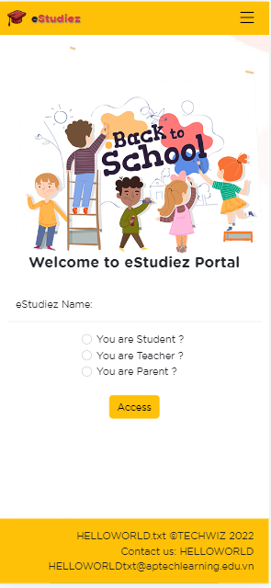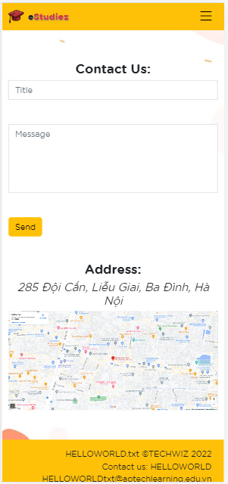iPhone 12 Pro (width – height: 399px – 844px):

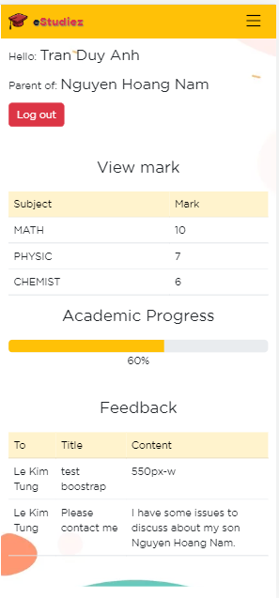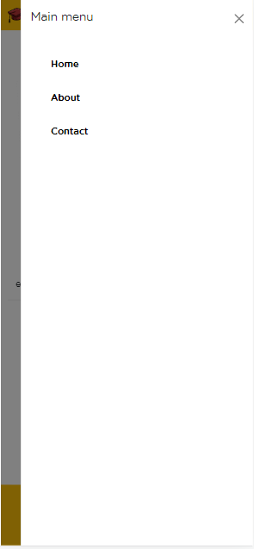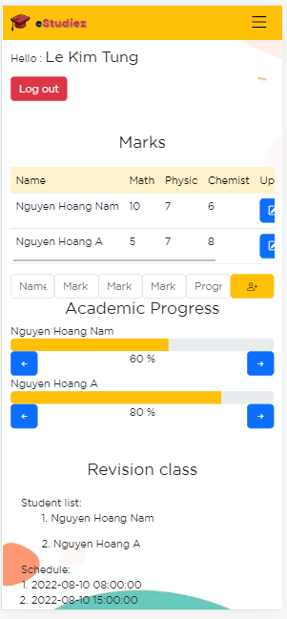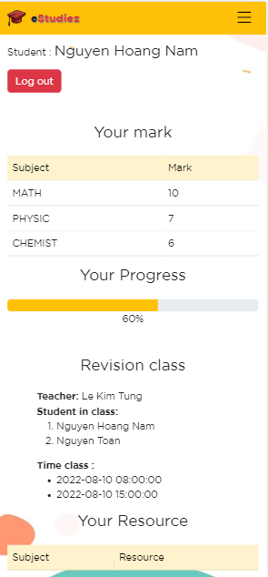

1. iPad Air (width – height: 820px – 1180px):

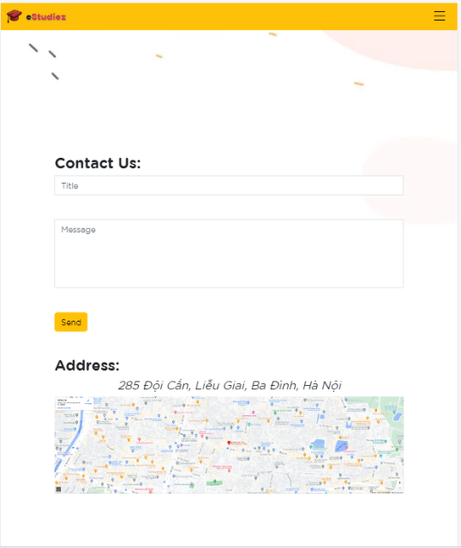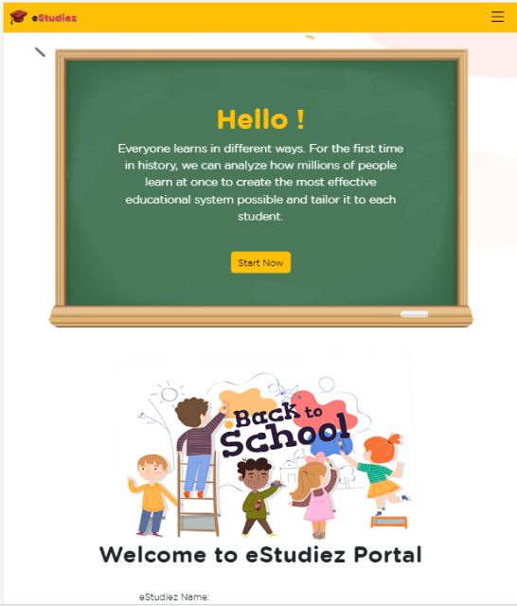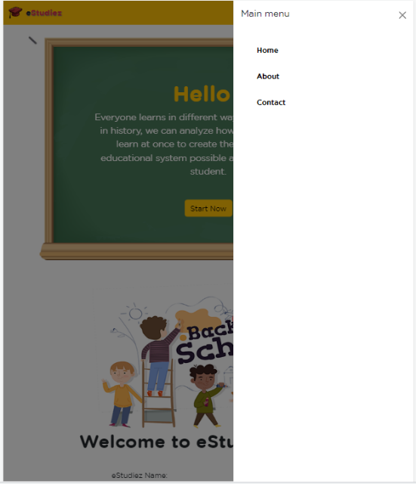

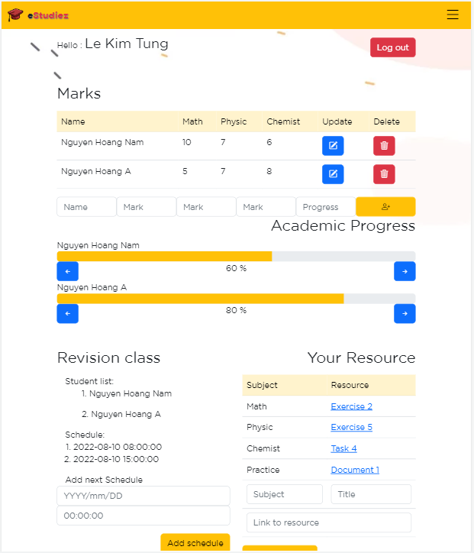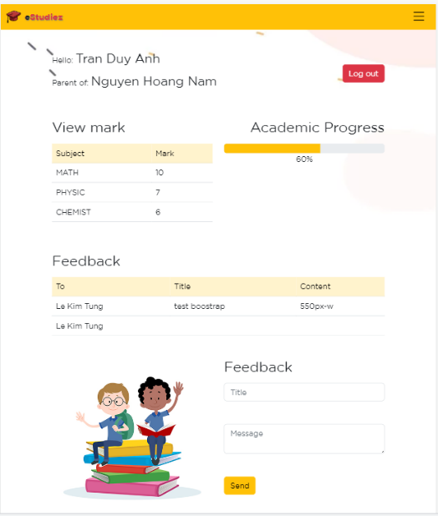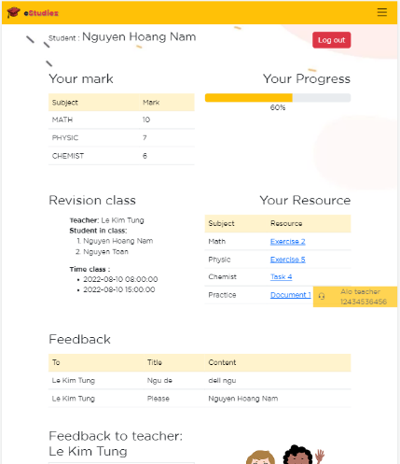

1. 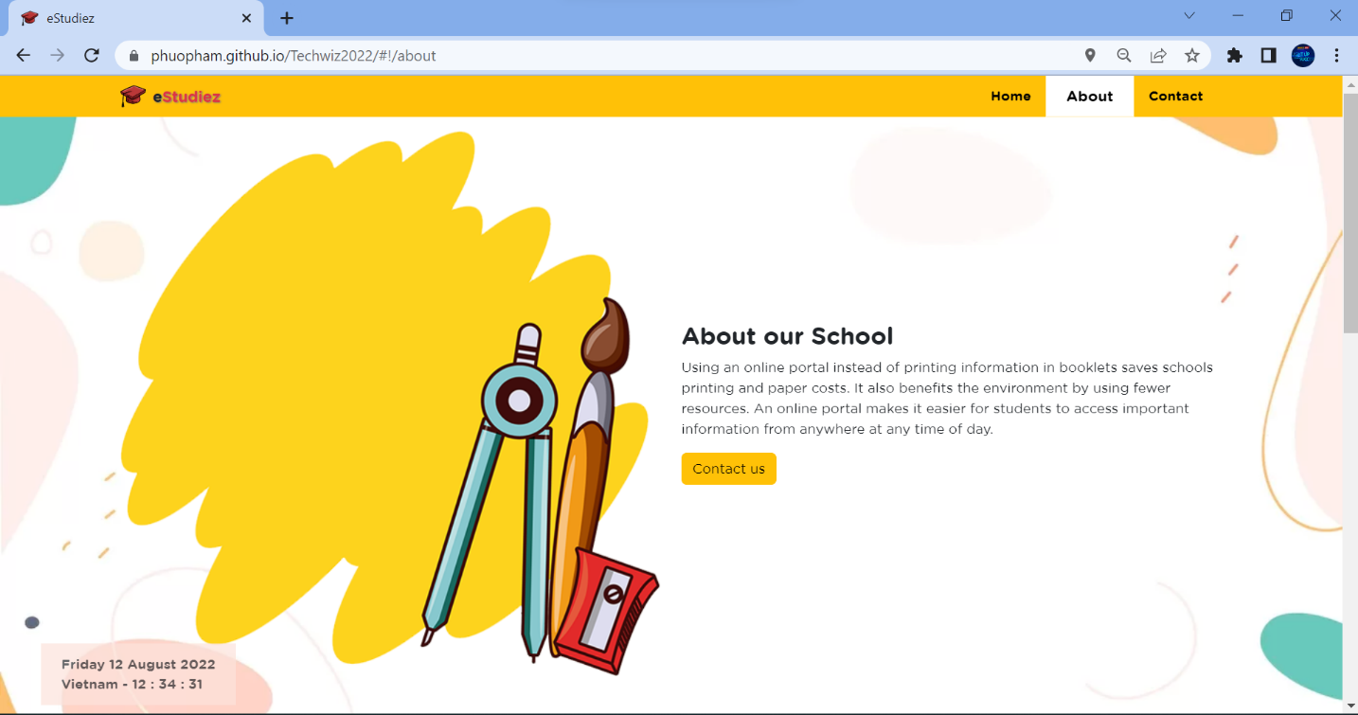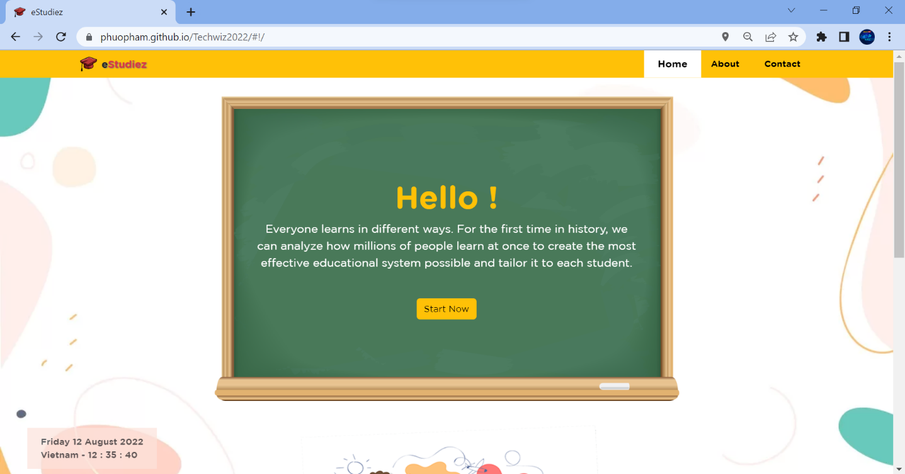Desktop (width – height: 1920px – 1080px):

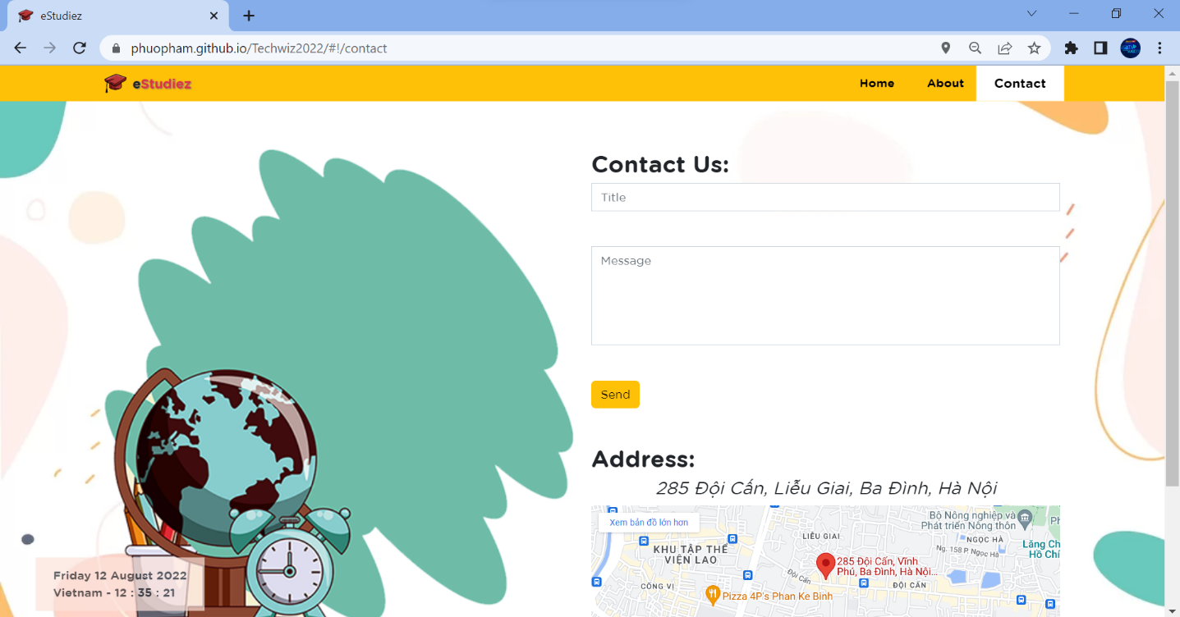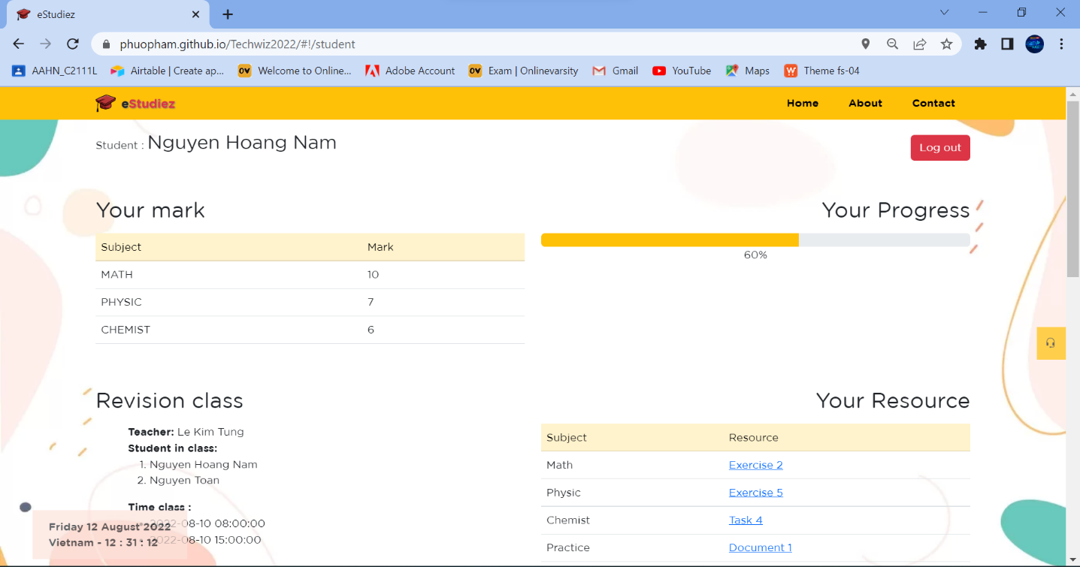

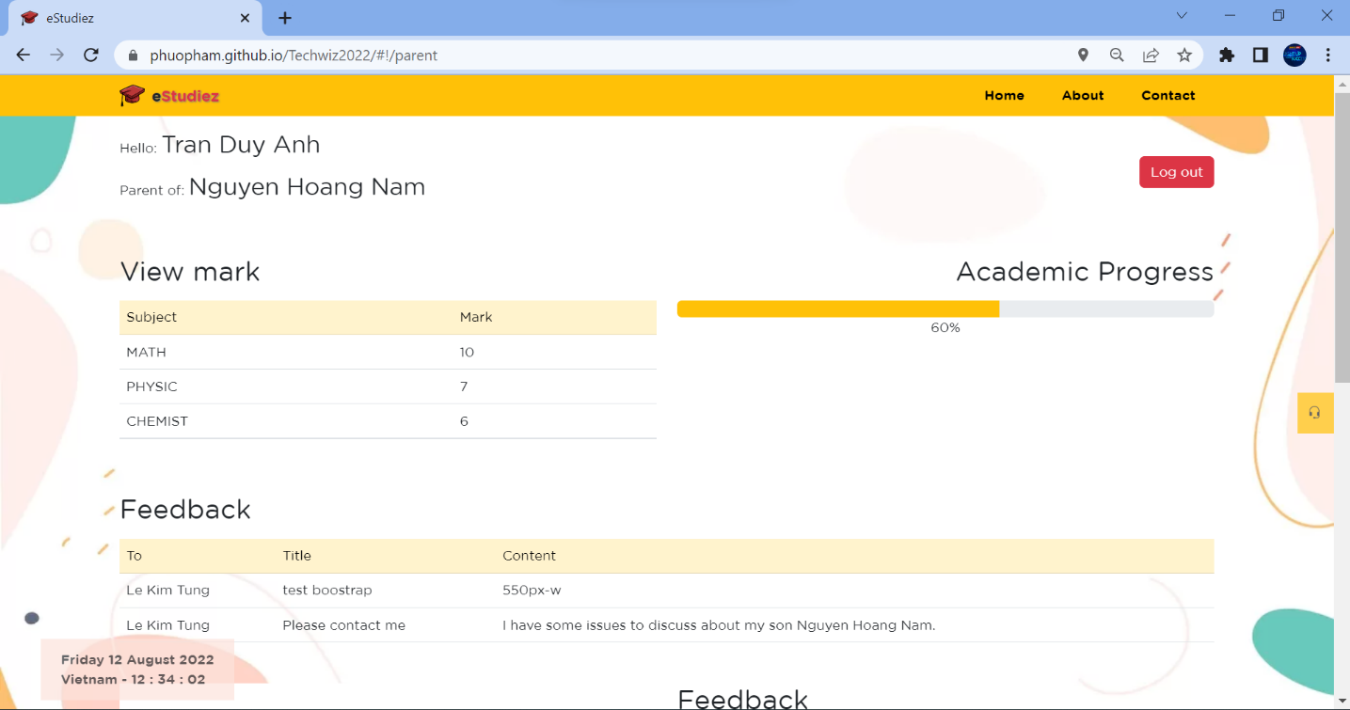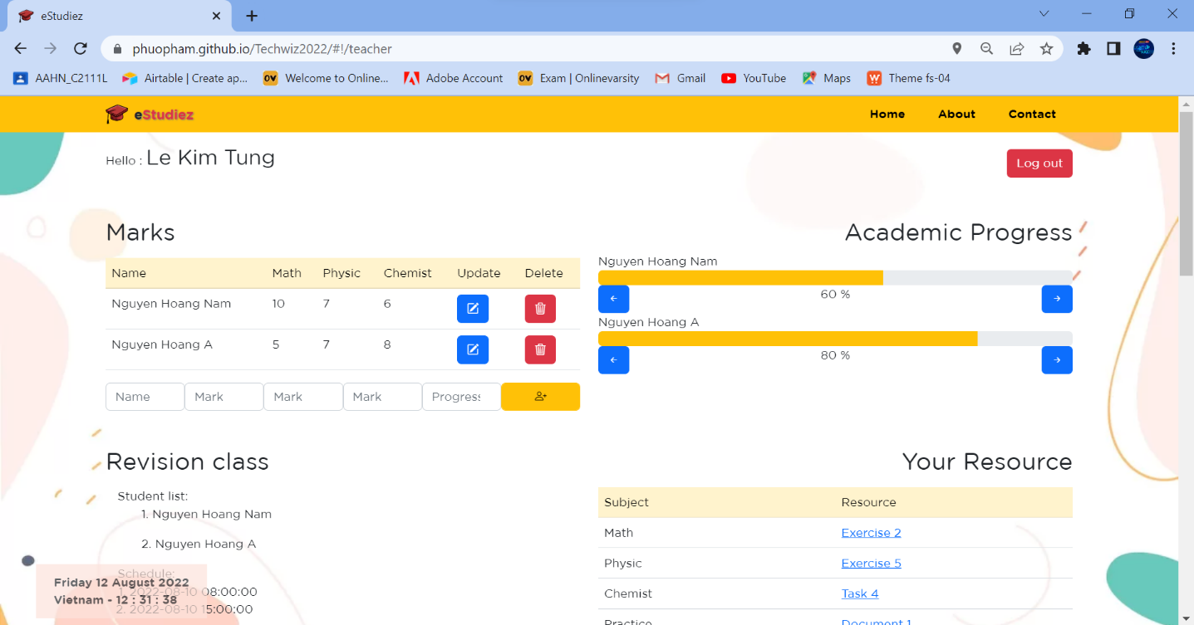

### FEATURE DESCRIPTION

Users click on the Start Now box to have the computer screen scroll down to log in form.

1. **Home page**

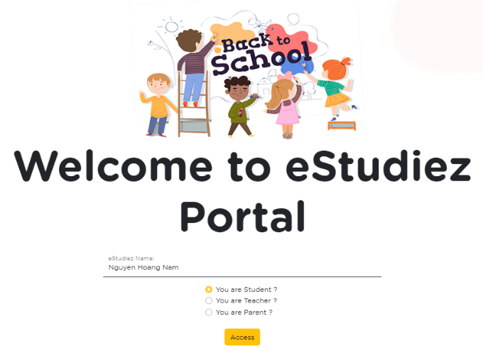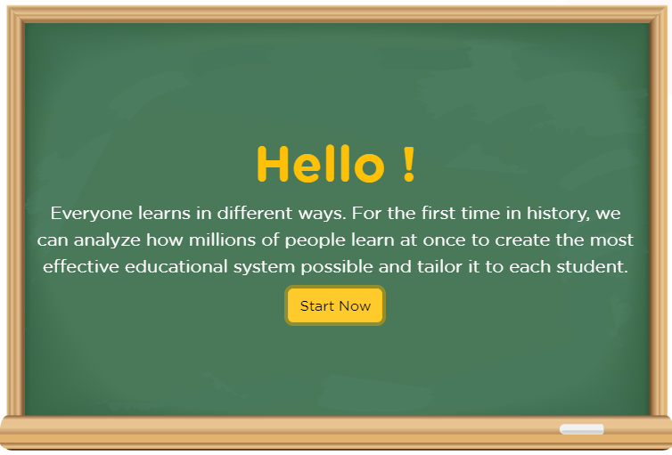

If the input data is correct, the login is successful, and corresponding page will be replaced.

The user enters their name and selects their role, and clicks on the Access box to sign in.

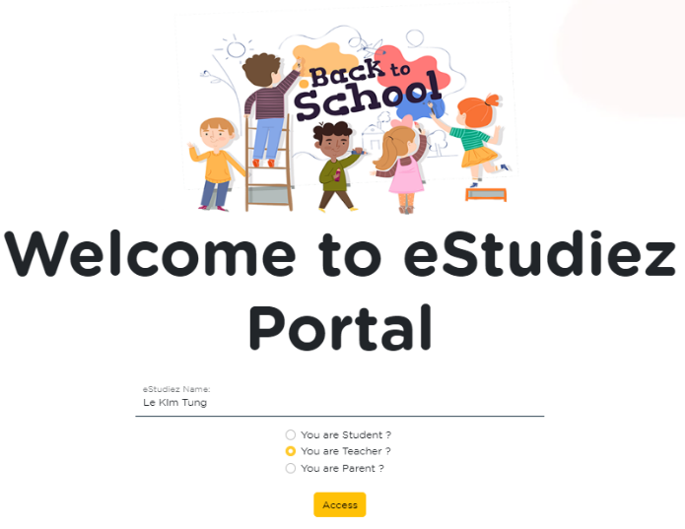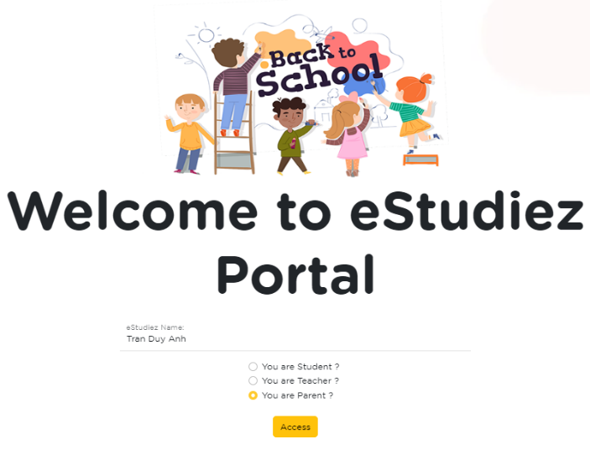

If the input data is correct, the login is successful, and corresponding page will be replaced.

The user enters their name and selects their role, and clicks on the Access box to sign in.

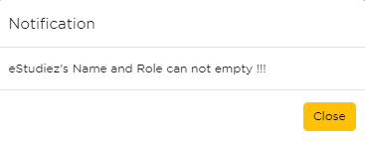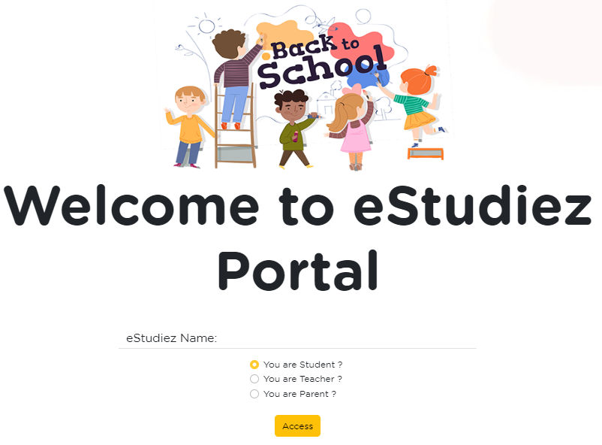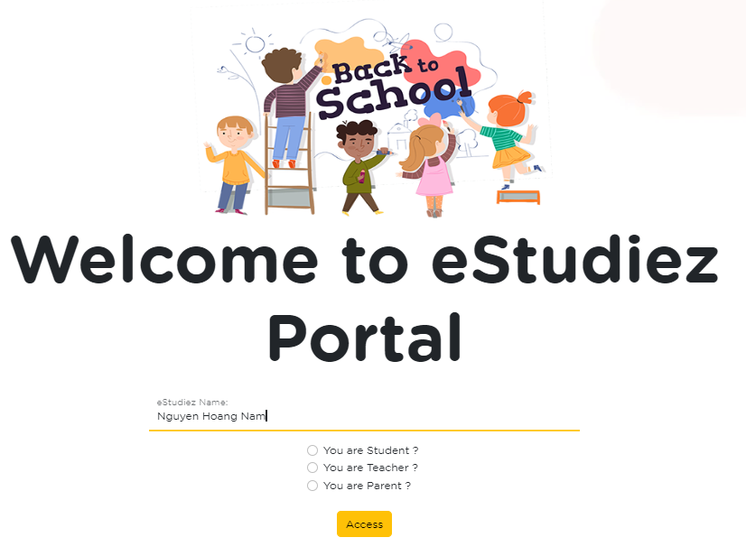

If the user is logged in with only their name or role, there is an error and message to the user.

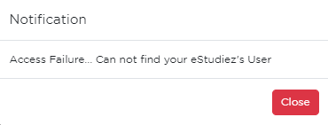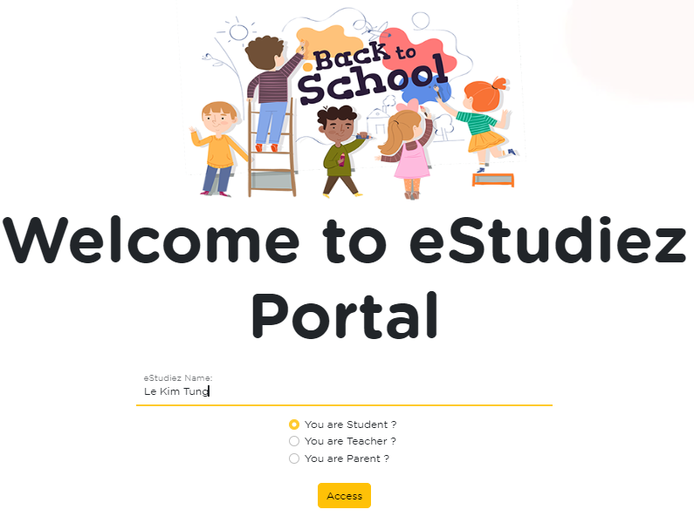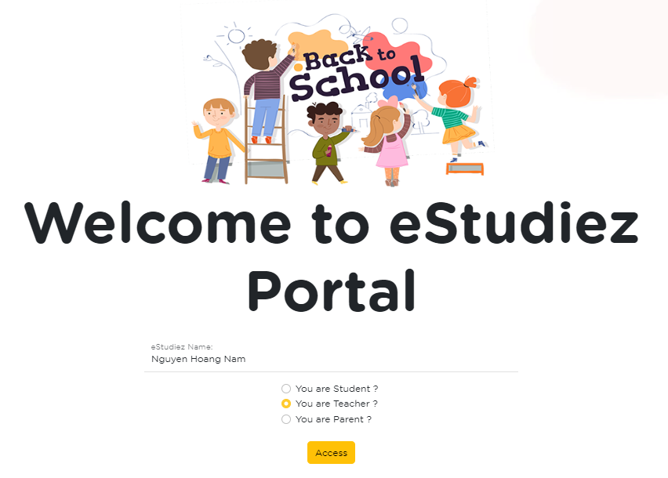

If the user is logged in with the correct name, the wrong role, or vice versa, there is an error and notify the user.

1. **Student page**

Display student information: full name, grades, learning progress, class information, and learning materials.

Log out current session, clear local storage, and return to the home page.

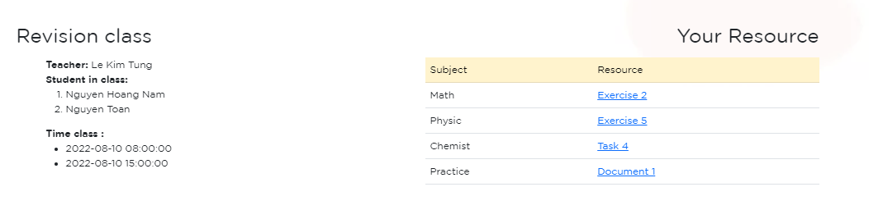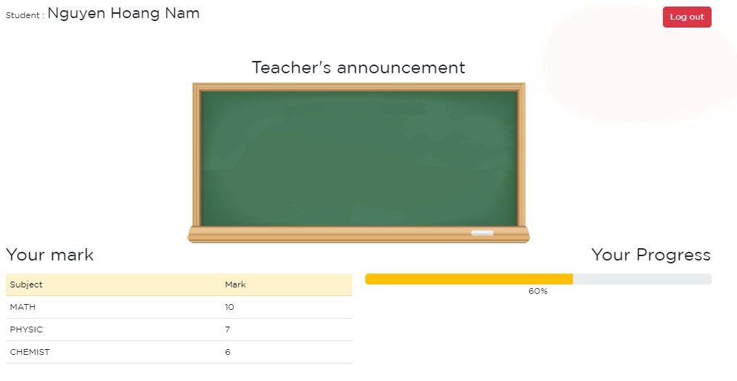

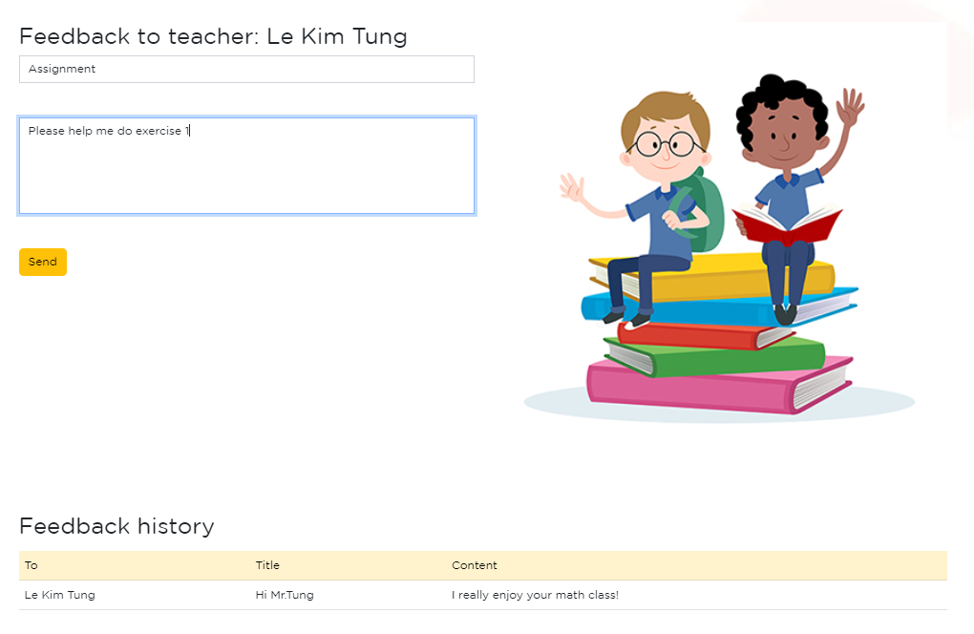

When feedback is submitted, an entry will be create in local storage. If the student access to the portal, feedback will be shown.

Feedback section provide communication channel for student to corresponding teacher.

1. 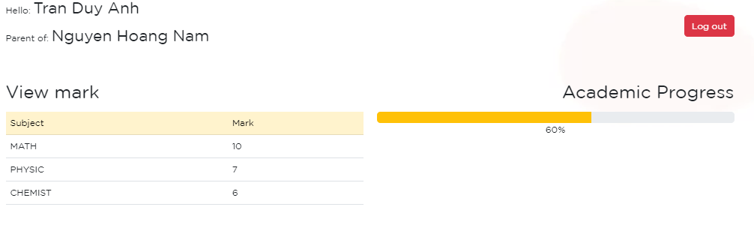**Parents page**

Log out current session, clear local storage, and return to the home page.

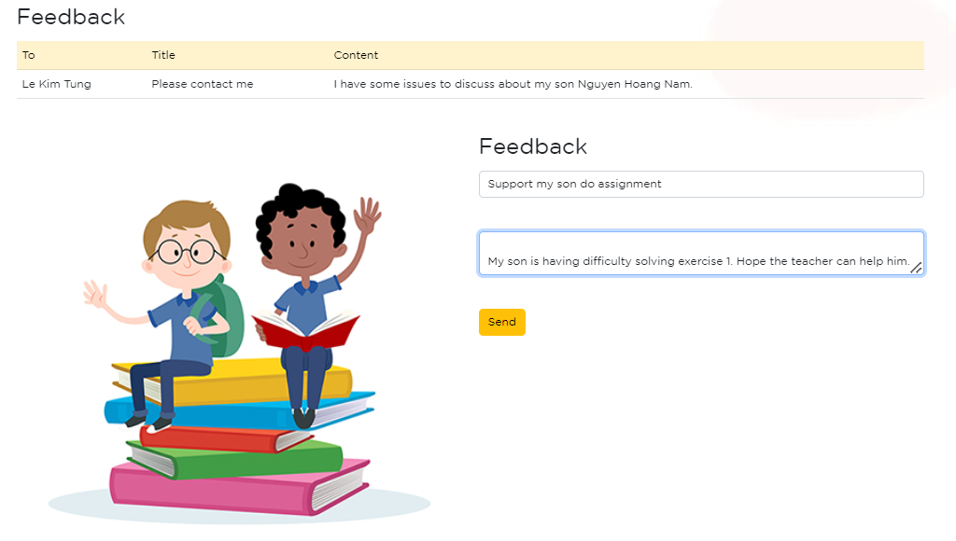

The feedback menu option will allow parents of students to provide their feedback or questions through the feedback form. There is a section showing feedback from teachers.

Display the student’s full name, parent-friendly greeting, grades, and academic progress.

1. 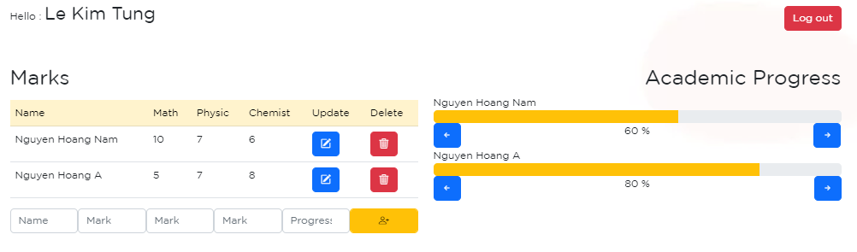**Teacher page**

On the left is where teachers add, edit and delete students and their grades. On the right is where to edit the learning progress.

Log out current session, clear local storage, and return to the home page.

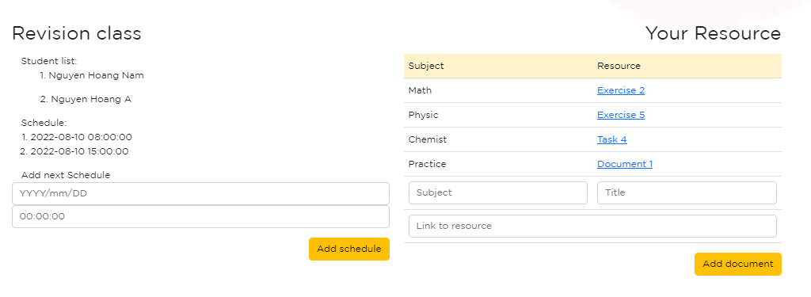

Where teachers add timetable and material for student.

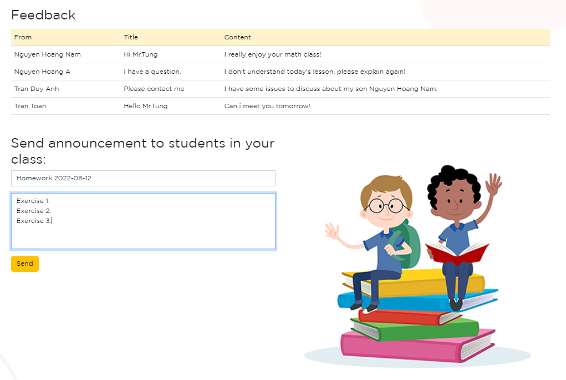

This is a section teachers write notices to send to student in class.

When feedback is submitted, an entry will be created in local storage. If the student access to the portal, feedback will be shown.

### EXTRA FEATURE

|  |  |
| --- | --- |
|  | * Display a visitor count at the top right corner of the page beside a logo image. **(because of the limit of technology, we use local storage to store visitor count)** * Menu options change color on hover and also after clicking. |
|  | * Display a continuous scrolling ticker at the bottom of the page with the current date, time, and location. |
|  | * Create add, update and delete student by using databinding. * Form update is displayed when teacher update information of student. |
|  | * Student and parents can send feedback to teacher. |
|  | * Route is protected when user not log in (**using local storage for author**). |
|  | * Teacher’s announcement will display on each student site when student log in. * Teacher can send announcement to all student in teacher’s class. |

### ENTITY RELATIONSHIP

Diagram showing the relationship of data between JSON files

### DATABASE DESIGN

According to the requirement specification, we decided to manipulate the JSON file with a structure of 3 JSON files as follows:

1. feedback.json

Contain a list of feedback. Each feedback has the following entry:

* Recipient name
* Sender name
* Title of the feedback
* Main content of the feedback

Data structure:

[

    {

        "from": "Tran Danh Tu",

        "to": "Tran Duy Anh",

        "title": "You are good at math",

        "message": "Please work hard on Physic"

    },

    {

        "from": "Le Kim Tung",

        "to": "Tran Duy Anh",

        "title": "You are so good at math",

        "message": "Help your friends"

    },

    {

        "from": "Tran Duy Anh",

        "to": "Le Kim Tung",

        "title": "You are not good at math",

        "message": "Please work hard"

    },

    {

        "from": "Nguyen Hoang Nam",

        "to": "Le Kim Tung",

        "title": "You are good at physic",

        "message": "Please help Nguyen Van A on exercise 5"

    }

]

1. revclass.json

Contain a list of teachers with their classes. Each of the items has the following entry:

* Name of responsible teacher
* Name of student
* Schedule for the next learning lesson

Data structure:

[

    {

        "studentname": "Nguyen Hoang Nam",

        "teacher": "Le Kim Tung",

        "time": "2022-08-10 08:00:00"

    },

    {

        "studentname": "Nguyen Toan",

        "teacher": "Le Kim Tung",

        "time": "2022-08-10 08:00:00"

    },

    {

        "studentname": "Nguyen Phuong",

        "teacher": "Nguyen Duy Anh",

        "time": "2022-08-10 14:00:00"

    },

    {

        "studentname": "Tran Nam",

        "teacher": "Nguyen Duy Anh",

        "time": "2022-08-10 14:00:00"

    }

]

1. students.json

Contain a list of students. Each student will have the following entry:

* Name of student
* Name of parent or guardian
* Name of responsible teacher
* Marks of 3 subjects
* Study the progress of the student, which is evaluated by the responsible teacher

Data structure:

[

    {

        "name": "Nguyen Hoang Nam",

        "mark": {

            "math": 10,

            "physic": 7,

            "chemist": 6

        },

        "parents": "Tran Duy Anh",

        "progress": "60",

        "teachername": "Le Kim Tung"

    },

    {

        "name": "Nguyen Hoang A",

        "mark": {

            "math": 5,

            "physic": 7,

            "chemist": 8

        },

        "parents": "Tran Toan",

        "progress": "80",

        "teachername": "Le Kim Tung"

    },

    {

        "name": "Nguyen Hoang V",

        "mark": {

            "math": 6,

            "physic": 8,

            "chemist": 8

        },

        "parents": "Le Kim Tung",

        "progress": "30",

        "teachername": "Tran Duy A"

    },

    {

        "name": "Nguyen Hoang S",

        "mark": {

            "math": 9,

            "physic": 5,

            "chemist": 7

        },

        "parents": "Tran Duc",

        "progress": "50",

        "teachername": "Tran Duy A"

    }

]

1. resources.json

Contain study resources. Each subject includes the following topics:

* Subject name
* Link
* Lesson title

Data structure:

[

    {

        "subject": "Math",

        "url": "http://esdudiez.edu.vn/asdsfgjsg",

        "title": "Exercise 2"

    },

    {

        "subject": "Physic",

        "url": "http://esdudiez.edu.vn/asdhjkjsg",

        "title": "Exercise 5"

    },

    {

        "subject": "Chemist",

        "url": "http://esdudiez.edu.vn/acvnfgjsg",

        "title": "Task 4"

    },

    {

        "subject": "Practice",

        "url": "http://esdudiez.edu.vn/xvbnvgjsg",

        "title": "Document 1"

    }

]

### STRESS TEST REQUEST

